COUNTDOWN UNDERWAY TO NAVARINO HILLS LAUNCH

AT COSTA NAVARINO

Preparations in full force for the completion of the newest golf destination in Europe

25 May 2021 – Messinia, Greece: With less than a year to go to the opening of Europe’s most eagerly-awaited 36-hole golf-design project – Navarino Hills at Costa Navarino in Greece – course preparations are gathering pace and are now 70 per cent complete.

Both of the new 18-hole courses at Navarino Hills – named as the ‘World’s Best New Golf Development’ at the 2020 World Golf Awards – have been designed by two-time Masters champion José María Olazábal, who has inherited an incredible canvas on which to pen the new designs.

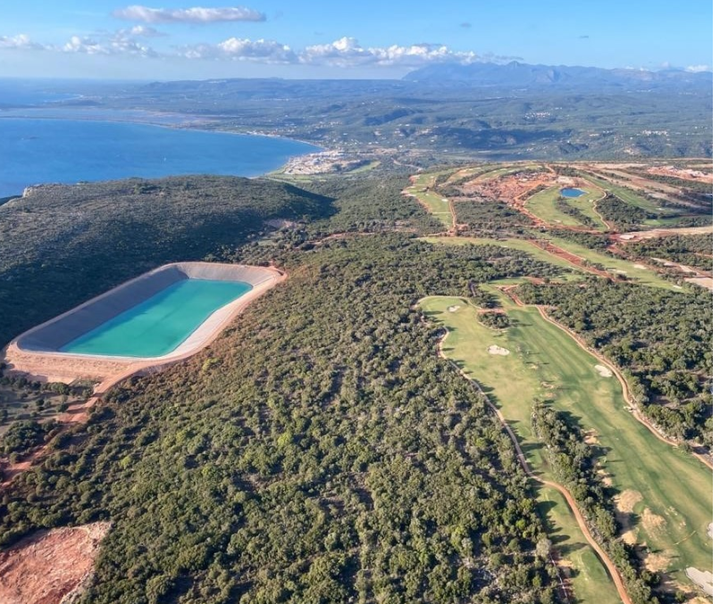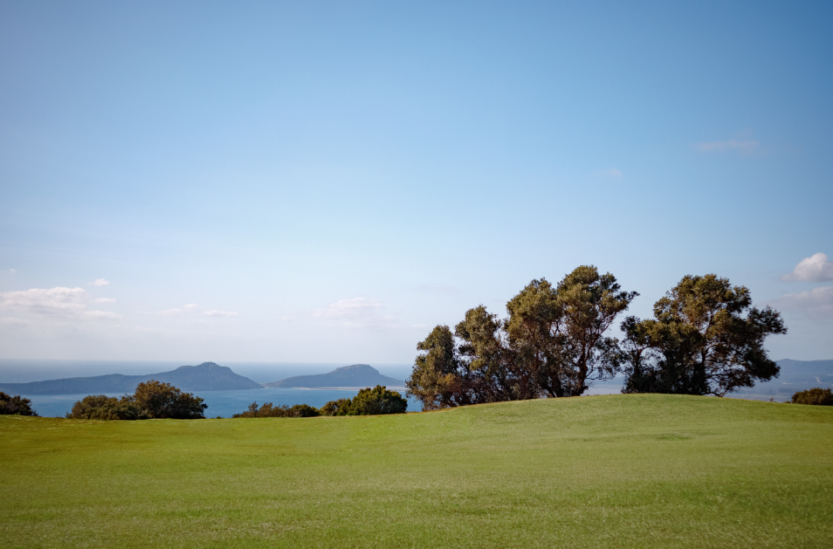

A unique location affords views to the sea, mountains and valleys, with the two courses measuring 6,366m and 6,280m in length respectively and featuring an average green size of 669m².

Olazábal explained: “The first course is closer to the cliffs … the breeze is always going to be a factor and it’s going to be a little bit tougher.

“… on the second course, you are more protected, and guests will experience increased tree-lined holes, with forest and mountains in the background. I think it’s going to be ideal for anybody who wants to come and play at Costa Navarino for a few days and enjoy a different feeling and a different view when they are playing.”

Even during the global pandemic, construction made fast progress at Navarino Hills. All infrastructure works, including electrical installations, rainwater drainage works and an additional irrigation lake of 15,000 m³, were completed last summer.

Full seeding has been finished on the first course, along with the maintenance building, cart paths and bunkers. Meanwhile, all the excavation work has been completed on the second course, with the next step to begin placing the topsoil on playing surfaces. In line with Costa Navarino’s commitment to sustainable development, a water reservoir with a capacity of 485,000m³ has been built to meet the irrigation needs of both courses, while 52,000 indigenous forest plants, shrubs and seasonal local flowers and herbs have been planted.

Nuno Sepulveda, General Manager at Dunes Golf SA, said: “We are delighted with the progress of the project and eager to welcome golf enthusiasts early next year. With a total of four signature courses, we believe Costa Navarino will truly become Europe’s newest golfing destination. Offering variety in playing experiences set in a striking natural landscape, paired with an idyllic climate and a wide range of premium leisure, sports and hospitality facilities, Navarino Hills is sure to have a strong appeal to the international golfing community.”
In addition, a new clubhouse is under construction and scheduled to be finished by December. Designed by acclaimed architect Lubomír Zeman and built using local stone materials, it aims to achieve class A+ in energy efficiency and will feature photovoltaic panels. When completed next spring, the Navarino Hills golf facilities will also include a driving range with a capacity for 60 people and a 15,000m² short game area.

Participants at the 5th Messinia Pro-Am will have the exclusive chance to play the first of the two courses in November, with the second layout scheduled to be completed early next year.

Navarino Hills will provide the ideal complement to Costa Navarino’s two signature golf courses, The Dunes Course (designed by Bernhard Langer in association with European Golf Design) and The Bay Course (created by Robert Trent Jones II).

When the two courses at Navarino Hills open for play in spring 2022, the Mediterranean’s prime sustainable destination will be in the rare position of offering its guests the challenge of four signature golf courses to enjoy within a 13km radius, further enhancing its status as one of Europe’s elite golf destinations.

For more information about Navarino Hills, please go to https://www.costanavarino.com/navarino-hills/ .

To find out more about Costa Navarino, please visit:
www.costanavarino.com
www.facebook.com/CostaNavarinoGolf
www.youtube.com/costanavarino
Instagram: @costanavarinogolf
Twitter: @costanavarinogolf
ENDS
Information for journalists
ABOUT COSTA NAVARINO
Costa Navarino is the prime, sustainable destination in the Mediterranean, located in the Greek region of Messinia in the southwest Peloponnese. One of the most unspoiled and breathtaking seaside Mediterranean landscapes, this area has been shaped by 4,500 years of history.
Its philosophy is driven by a genuine desire to promote Messinia, while protecting and preserving its natural beauty and heritage. It will comprise a number of distinct sites featuring five-star deluxe hotels, luxury private residences, conference facilities, spa and thalassotherapy centres, signature golf courses, as well as a wide range of unique year-round activities for adults and children.
Navarino Dunes, the first area, is home to two luxury five-star hotels, The Romanos, a Luxury Collection Resort, and The Westin Resort Costa Navarino; Navarino Residences, a collection of luxury villas for private ownership; and The Residences at The Westin Resort Costa Navarino – fully furnished resort apartments for sale; the signature golf course The Dunes Course; Anazoe Spa, a 4,000m2 spa and thalassotherapy centre; the state-of-the-art conference centre House of Events; specially designed facilities for children; and a variety of gastronomy venues, sports, outdoor and cultural activities.
Navarino Bay, the second area, is home to the signature golf course, The Bay Course and to the earth-sheltered Bay Clubhouse, while an ultra-luxury, all suite and pool villas resort is currently under construction, alongside an upscale, vibrant, lifestyle resort at the nearby site Navarino Waterfront.
At Navarino Hills, two new 18-hole signature golf courses are also being constructed and will open in spring 2022.
PRESS IMAGES
For press images, please visit website www.costanavarino.com/media-press/
Password: Νestor
----------------------------------------------------------------------------------------------
For media enquiries please contact:
Valia Vanezi, Senior Communications Manager
Tel: +30 6980 071311
email: vvanezi@temes.gr

Maria Karapandeli, communications manager
Tel.: +30 6944 895518
email: mkarapandeli@temes.gr
TEMES S.A. – Developers of Costa Navarino
www.costanavarino.com

Pete Simm, editorial manager
Tel: +44 1730 711 926
email: petes@theazaleagroup.com

