# **COSTA NAVARINO TO UNVEIL NAVARINO HILLS**

**AT 2021 MESSINIA PRO-AM**

**Register now for the biggest tournament yet, played across three courses**

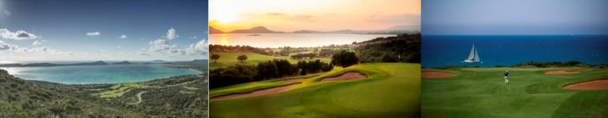

**7 April 2021 - Messinia, Greece –** The fifth annual [**Messinia Pro-Am**](https://messiniaproam.costanavarino.com/) has been confirmed for **24-27 November 2021** and for the first time attendees will have the opportunity to play across three courses, including the brand new José María Olazábal-designed West Course at [**Navarino Hills**](https://www.costanavarino.com/navarino-hills/)Costa Navarino, and the award-winning [**The Dunes Course**](https://www.costanavarino.com/golf-resort/dunes-course/)and [**The Bay Course**](https://www.costanavarino.com/golf-resort/bay-course/).

The 54-hole international event – which saw record breaking attendance in 2020 with more than 20 participating countries and 50 teams-has welcomed professional and celebrity golfers over the years, such as Bill Murray, Mike Tindall and Sepp Maier.

Sanctioned by the [Confederation of Professional Golf](https://cpg.golf/) and held under the auspices of the PGAs of Greece and the Hellenic Golf Federation, this year’s Messinia Pro-Am will feature a record entry of 75 teams with professionals competing for a €50,000 prize fund under the Messinian sun.

An established part of the global golf calendar and with a host of top professionals and celebrities competing, the four-day event also includes a fascinating programme of themed events and dinners with the emphasis on fun and friendship.

Navarino Hills, recently named as the **‘World’s Best New Golf Development’** at the **2020 World Golf Awards** stretches over 500 hectares of rugged natural terrain overlooking Navarino Bay and provides the ideal complement to the existing courses. Designed by two-time Masters champion and Ryder Cup legend **José María Olazábal**, the two new courses will both play to Par 72 and measure 6,466m and 6,280m respectively and stretch over 125 hectares (1,250,000sq.m.), overlooking the historic Bay of Navarino and the surrounding hills.

When the project is fully completed in spring 2022, the Mediterranean’s prime, sustainable destination will be in the enviable position of being able to offer its guests four signature 18-hole golf courses – all within a 13km radius.

Surrounded by olive groves and overlooking the historic Bay of Navarino, the par-71, 5,422m **The Bay Course** was designed by Robert Trent Jones II and meanders through three distinct settings – seaside, canyon, and grove – to provide striking contrasts. Golfers can also enjoy the newly opened and award-winning earth-sheltered Bay Clubhouse which blends seamlessly into the natural landscape.

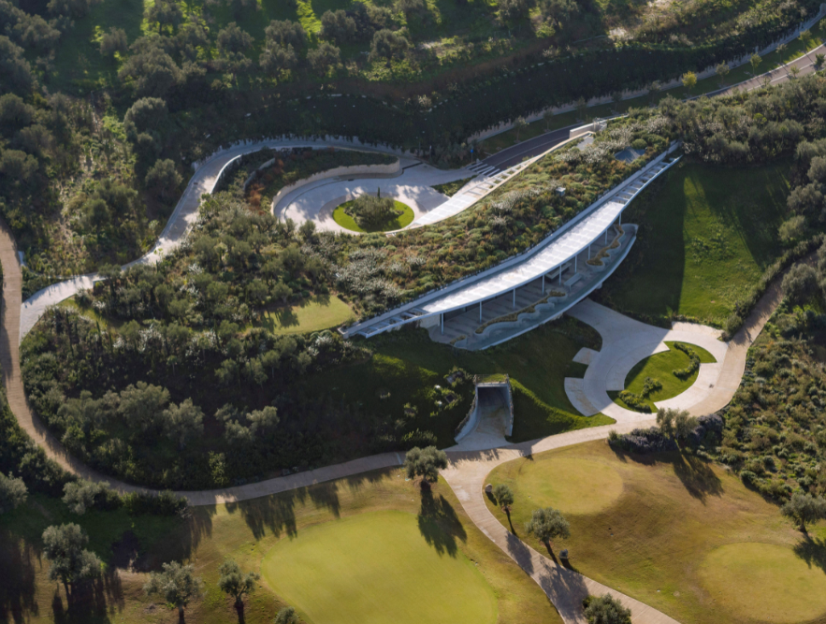 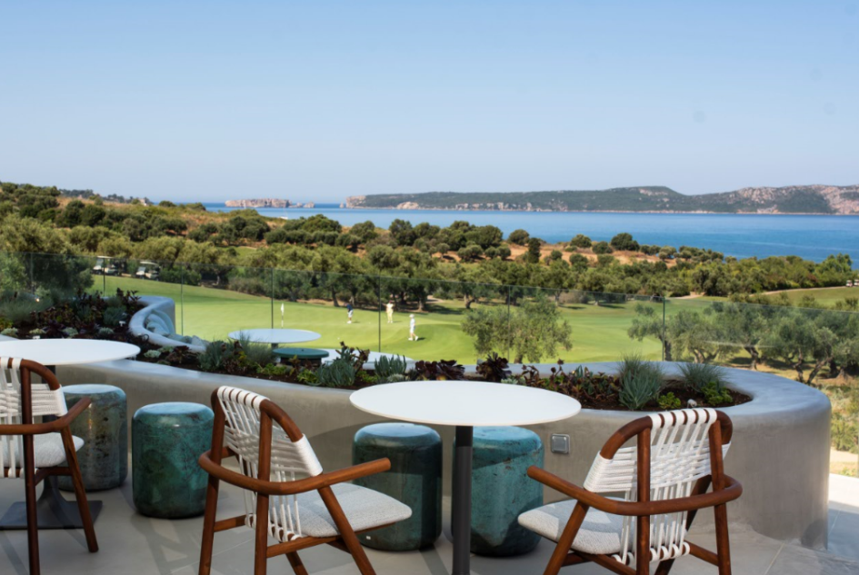

Complementing this, the par-71, 6,018m, Bernhard Langer and EGD-designed **The Dunes Course,** offers spectacular sea and river views and incorporates links-style features in areas closest to the sea, while occasionally venturing into olive and fruit groves.

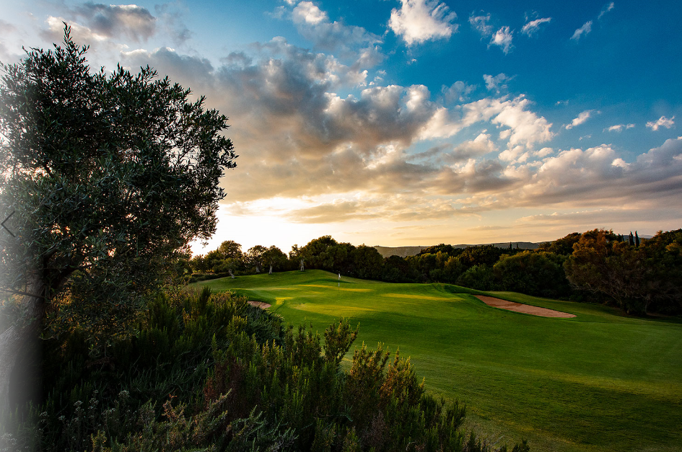

The official carrier of the Messinia ProAm for the 5th consecutive year is **AEGEAN Airlines** ([www.aegeanair.com](http://www.aegeanair.com)), a member of Star Alliance, the strongest global aviation alliance who is in partnership with Costa Navarino, the Confederation of Professional Golf (CPG) and PGA of Greece. Aegean offers special airline ticket prices for Messinia ProAm participants.

**Erasmus Conference & Events,** is the official event organizer and travel partner, which is coordinating and ensuring a smooth registration and accommodation process.

Team registration – which is strictly on a first-come, first-served basis is now open.

For more information on the 2021 Messinia Pro-Am, please visit [messiniaproam.costanavarino.com](https://messiniaproam.costanavarino.com/)

You can view the 2021 Messinia Pro-Am preview video [here](https://www.youtube.com/watch?v=aGkpfeavYRw)

To find out more about Costa Navarino, please visit:

[www.costanavarino.com](http://www.costanavarino.com)

[www.facebook.com/CostaNavarinoGolf](http://www.facebook.com/CostaNavarino#Golf)

[www.youtube.com/costanavarino](http://www.youtube.com/costanavarino)

Instagram: @costanavarinogolf

Twitter: @costanavarinogolf

**ENDS**

Information for journalists

**ABOUT COSTA NAVARINO**

Costa Navarino is the prime, sustainable destination in the Mediterranean, located in the Greek region of Messinia in the southwest Peloponnese. One of the most unspoiled and breathtaking seaside Mediterranean landscapes, this area has been shaped by 4,500 years of history.

Its philosophy is driven by a genuine desire to promote Messinia, while protecting and preserving its natural beauty and heritage. It will comprise a number of distinct sites featuring five-star deluxe hotels, luxury private residences, conference facilities, spa and thalassotherapy centres, signature golf courses, as well as a wide range of unique year-round activities for adults and children.

Navarino Dunes, the first area, is home to two luxury five-star hotels, The Romanos, a Luxury Collection Resort, and The Westin Resort Costa Navarino; Navarino Residences, a collection of luxury villas for private ownership; and The Residences at The Westin Resort Costa Navarino – fully furnished resort apartments for sale; the signature golf course The Dunes Course; Anazoe Spa, a 4,000m2 spa and thalassotherapy centre; the state-of-the-art conference centre House of Events; specially designed facilities for children; and a variety of gastronomy venues, sports, outdoor and cultural activities.

Navarino Bay, the second area, is home to the signature golf course, The Bay Course and to the earth-sheltered Bay Clubhouse, while an ultra-luxury, all suite and pool villas resort is currently under construction, alongside an upscale, vibrant, lifestyle resort at the nearby site Navarino Waterfront.

At Navarino Hills, two new 18-hole signature golf courses are also being constructed and will open in spring 2022.

**PRESS IMAGES**

For press images, please visit website [www.costanavarino.com/media-press/](http://www.costanavarino.com/media-press/)

Password: Νestor

----------------------------------------------------------------------------------------------

**For media enquiries please contact:**

Valia Vanezi, Senior Communications Manager

Tel: +30 6980 071311

email: [vvanezi@temes.gr](mailto:vvanezi@temes.gr)

Maria Karapandeli, communications manager

Tel.: +30 6944 895518

email: [mkarapandeli@temes.gr](mailto:mkarapandeli@temes.gr)

TEMES S.A. – Developers of Costa Navarino

[www.costanavarino.com](http://www.costanavarino.com)

Luke Frary, account director

Tel: +44 1730 711 920

email: [luke.frary@theazaleagroup.com](mailto:luke.frary@theazaleagroup.com)

[www.theazaleagroup.com](http://www.theazaleagroup.com)